

A Project Report on
SPAM DETECTION IN EMAILS
Submitted in partial fulfilment of requirements for the award of the Degree of

BACHELOR OF TECHNOLOGY
in

ARTIFICIAL INTELLIGENCE AND DATA SCIENCE

Under the guidance of

Mrs. SUBHA SRI S

IBM CORPORATE TRAINER

Submitted by

NIVETHA R T [REG NO: 927623BAD071]

DEPARTMENT OF ARTIFICIAL INTELLIGENCE AND DATA SCIENCE

M KUMARASAMY COLLEGE OF ENGINEERING, KARUR

(Autonomous)

Karur 639-113



M. KUMARASAMY COLLEGE OF ENGINEERING

(Autonomous Institution affiliated to Anna University, Chennai)

BONAFIDE CERTIFICATE

Certified that this project report on “SPAM DETECTION EMAILS” is the Bonafide work NIVETHA R T (927623BAD071) who carried out the project work during the academic year 2025- 2026 under my supervision.

Signature Signature

Mrs. SUBHA SRI S Dr. A. SELVI M.E., Ph.D.,
IBM CORPORATE TRAINER, HEAD OF THE DEPARTMENT,
Department of Artificial Intelligence, Department of Artificial Intelligence,
M. Kumarasamy College of Engineering, M. Kumarasamy College of Engineering, Thalavapalayam, Karur -639 113. Thalavapalayam, Karur -639 113.

ABSTRACT

Email communication has become an essential part of modern digital interaction, but the increasing volume of unsolicited and malicious spam emails poses significant security and productivity challenges. This project focuses on developing an efficient spam detection system using Natural Language Processing (NLP) techniques integrated with Apache Spark MLlib to ensure high-performance classification even with large-scale datasets. The system processes raw email text through tokenization, cleaning, and feature extraction to convert unstructured text into meaningful numerical representations. Using machine learning algorithms such as Logistic Regression or Naïve Bayes, the model is trained to accurately classify emails as “Spam” or “Not Spam.” Spark's distributed processing capabilities significantly enhance speed and scalability, making the solution suitable for real-world applications involving massive email corpora. The final output provides reliable classification results that support automated email filtering, improved user safety, and enhanced email management efficiency. This project demonstrates how advanced NLP and big data technologies can be combined to deliver a robust, scalable, and intelligent email spam detection system.

- Keywords: Spam Detection, NLP (Natural Language Processing), Apache Spark, Spark MLlib, Text Classification, Tokenization, Email Filtering, Machine Learning, Feature Extraction, and Big Data Processing are the major concepts involved in the project.

TABLE OF CONTENTS

CHAPTER | TITLE | PAGE NO
1 | INTRODUCTION | 5
2 | OBJECTIVES | 6
3 | EXISTING SYSTEM | 7
4 | PROPOSED SYSTEM | 9
5 | TOOLS AND TECHNOLOGIES | 12
6 | METHODOLOGY | 14
7 | IMPLEMENTATION | 17
8 | OUTPUT | 20
9 | CONCLUSION | 22
10 | FUTURE SCOPE | 23
11 | REFERENCES | 24

CHAPTER 1 INTRODUCTION

In today’s digital communication ecosystem, email remains one of the most widely used platforms for personal, academic, and business interactions. However, the rapid increase in unsolicited and malicious emails—commonly known as spam—poses significant risks to users. Spam emails can contain phishing links, malware attachments, fraudulent promotional content, and deceptive messages designed to extract sensitive information or cause financial loss. The sheer volume and complexity of these emails make manual filtering ineffective and highlight the need for intelligent, automated solutions.

Traditional spam filtering methods rely heavily on predefined rules, keyword matching, or manual blacklists, which often fail to detect newly emerging spam patterns. These rule-based systems lack flexibility and cannot adapt to evolving attacker strategies, leading to higher false positives and false negatives. With the exponential growth of digital communication and the increasing sophistication of cyber threats, modern spam detection requires advanced techniques capable of analyzing large-scale email data efficiently and accurately.

Natural Language Processing (NLP), combined with machine learning, offers powerful tools for understanding email content, extracting meaningful features, and identifying hidden patterns in text. Techniques such as tokenization, text vectorization, and classification algorithms enable systems to distinguish between legitimate and spam messages with high precision. However, as email datasets grow to millions of records, conventional processing techniques become inefficient and slow. This challenge calls for scalable, distributed platforms capable of handling big data.

Apache Spark, with its in-memory computation capabilities and distributed processing framework, provides an ideal solution for large-scale spam detection. Spark MLlib facilitates the implementation of machine learning models such as Logistic Regression, Naïve Bayes, Decision Trees, and Random Forests, enabling fast training and accurate classification even with large datasets. The integration of NLP preprocessing pipelines with Spark's distributed architecture allows for real-time email analysis, efficient feature extraction, and scalable model building.

CHAPTER 2
OBJECTIVES

The primary objective of this project is to develop an intelligent and scalable spam detection system capable of accurately classifying emails as spam or legitimate by leveraging Natural Language Processing (NLP), Machine Learning, and the distributed processing power of Apache Spark. Modern email communication generates massive volumes of text data, and distinguishing harmful or unwanted emails from genuine messages requires advanced analytical techniques. By collecting, preprocessing, and analyzing email content, the system aims to identify meaningful linguistic patterns, suspicious keywords, structural anomalies, and contextual clues that are strongly associated with spam behavior.

At the core of this project lies the application of machine learning algorithms that can effectively learn from large datasets and adapt to evolving spam techniques. These models are designed to extract relevant features from raw text—such as token frequency, n-grams, message structure, and metadata and use them to classify emails with high precision. The objective is to develop a predictive framework that minimizes false positives and false negatives, ensuring that legitimate communication remains uninterrupted while harmful or deceptive messages are accurately detected. Through the use of Spark MLlib, the system is optimized to process large-scale datasets efficiently, enabling fast training, real-time classification, and support for continuous model updates.

Beyond automated classification, the project aims to support users and organizations by enhancing email security, reducing exposure to phishing attacks, and improving productivity by minimizing inbox clutter. The integrated system will also provide analytical dashboards, performance reports, and real-time filtering capabilities, ensuring that stakeholders can easily interpret detection results and make informed decisions. By incorporating distributed NLP processing and scalable machine learning pipelines, the project contributes to building a more secure communication environment that adapts dynamically to new threats.

Ultimately, this project focuses on transforming unstructured email data into meaningful insights that strengthen cyber safety. By combining big data processing with intelligent spam detection techniques, it highlights the potential of modern analytical technologies in safeguarding digital communication and preventing security breaches in an increasingly connected world.

CHAPTER 3
EXISTING SYSTEM

In the current digital environment, email remains one of the most widely used communication platforms for personal, professional, and commercial exchanges. However, traditional email systems rely heavily on rule-based filters and static keyword-matching techniques to identify spam messages. These existing methods only block emails based on predefined patterns, simple heuristics, or blacklisted addresses, making them inadequate against rapidly evolving spam strategies such as phishing, malware links, promotional blasts, and deceptive social engineering content. Most existing email filtering solutions offer basic categorization and do not incorporate advanced NLP or machine learning to analyze linguistic patterns, contextual meaning, or user behavior. As a result, many spam emails bypass the filters, while sometimes legitimate emails are incorrectly marked as spam. Furthermore, existing systems often lack scalability and struggle to process large volumes of email data in real time, making them unsuitable for modern enterprise-level communication platforms. Overall, current email filtering techniques provide reactive rather than intelligent protection, leaving users vulnerable to cyber-attacks and inbox clutter.Limited Predictive Capabilities

3.1 Limited Contextual and Predictive Capabilities
Most existing spam detection systems rely on rule-based filtering, keyword lists, or simple statistical models that do not understand the deeper meaning or context of email content. These systems fail to analyze sentence structure, patterns, semantic relationships, or subtle malicious intent embedded in modern spam messages. As a result, they cannot accurately predict or identify new, unseen spam patterns. The absence of advanced NLP techniques limits their ability to classify sophisticated spam such as targeted phishing, business email compromise (BEC), or contextually crafted fraud messages.

3.2 Lack of Scalability and Big Data Processing
Traditional email filtering systems are not designed to handle massive email traffic generated by organizations or cloud-based communication platforms. As the volume of email data increases, rule-based filters experience performance bottlenecks and become slow or unreliable. Without support for distributed processing frameworks like Apache Spark, existing systems struggle to process large datasets, retrain models efficiently, or perform real-time classification. This lack of scalability significantly reduces their effectiveness in modern enterprise environments.
.

3.3 High False Positives and False Negatives
Many existing systems misclassify genuine emails as spam or allow dangerous spam messages to slip into the inbox. Static filters often misinterpret harmless phrases as suspicious while completely missing well-crafted phishing emails. These inaccuracies lead to user frustration, loss of important communication, and increased vulnerability to cyber threats. Inconsistent classification also makes the system unreliable for organizations that require precise and secure communication channels.

3.4 Inability to Adapt to Evolving Spam Techniques
Spam techniques evolve rapidly, with attackers frequently modifying email formats, wording, and sender identities. Traditional systems lack the capability to learn from new data or update their rules dynamically. Without machine learning or continuous model retraining, these systems cannot adapt to emerging patterns such as spam campaigns delivered through new domains, personalized phishing content, or AI-generated spam messages. This limitation makes existing systems outdated and ineffective against modern threats.

3.5 Reliance on Manual Rule Updates
Many older spam detection systems require administrators to manually update rules, patterns, or blacklists. This reactive process is time-consuming, prone to human error, and fails to address large-scale spam attacks in real time. Since spam evolves continuously, manual updates are unable to keep pace with new threats, resulting in delayed protection and reduced filter accuracy.

3.6 Data Privacy and Security Concerns
Traditional email filtering platforms often store email content on centralized servers without strong encryption or privacy controls. This exposes users to risks such as unauthorized access, data breaches, or misuse of sensitive information. Additionally, many systems lack secure logging and monitoring mechanisms, which are crucial for detecting suspicious activities. These privacy limitations reduce user trust and make such systems unsuitable for environments that require strict data protection standards.

CHAPTER 4

PROPOSED SYSTEM
The proposed system introduces an intelligent, machine-learning–driven framework capable of accurately detecting spam emails using Natural Language Processing (NLP) and Apache Spark MLlib. Instead of relying on traditional rule-based filters, this system utilizes advanced text-processing techniques, feature extraction, and scalable machine learning algorithms to classify email messages as Spam or Not Spam. By analyzing linguistic patterns, keyword distributions, message structures, and contextual cues, the system can detect both common and sophisticated forms of spam such as phishing, promotional fraud, and malicious links.
Unlike conventional email filters that react only after a pattern is manually identified, the proposed system provides a data-driven, adaptive solution. Through continuous learning and distributed processing, the system efficiently handles large email datasets while improving classification accuracy. The objective is to offer a fast, reliable, and scalable framework for modern email environments where cyber threats evolve rapidly.
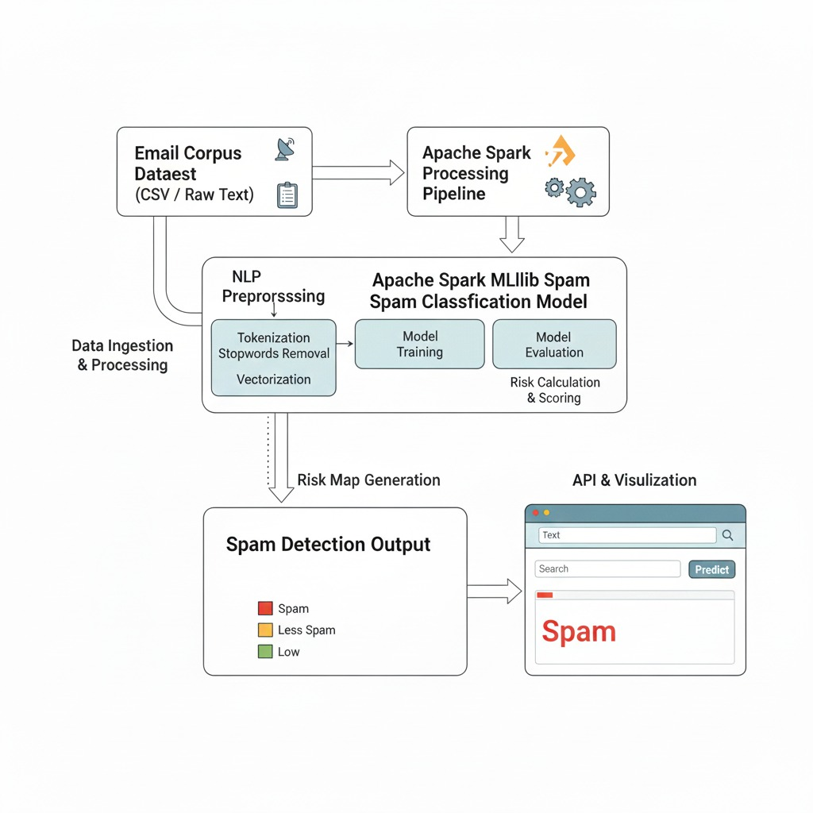
4.1 Automated Email Data Acquisition and Preprocessing
The system begins by importing and preparing email datasets, which typically include raw email text and corresponding labels (spam or ham). Since unprocessed text usually contains noise such as punctuation, stopwords, URLs, unnecessary symbols, and inconsistent casing, an automated preprocessing pipeline is applied. This pipeline includes tokenization, stopword removal, lowercasing, stemming or lemmatization, and removal of unwanted characters. Spark’s distributed processing ensures efficient handling of large volumes of emails. The cleaned text is then converted into structured formats suitable for machine learning.
4.2 NLP-based Feature Extraction and Vectorization
At the core of the preprocessing pipeline lies the transformation of email text into numerical features. Using NLP techniques such as CountVectorizer or TF–IDF (Term Frequency–Inverse Document Frequency), the system converts textual information into meaningful feature vectors. These representations capture essential patterns in word frequency and importance within the email body. By analyzing the linguistic structure of messages, the model can differentiate between legitimate communication and spam content. Spark MLlib ensures scalable feature extraction across large datasets.

4.3 Intelligent Spam Classification Using Machine Learning Models
The system employs machine learning classifiers such as Logistic Regression, Naïve Bayes, or Random Forest provided by Spark MLlib. These models learn from labeled training data to predict whether an incoming email belongs to the Spam or Not Spam category. The classifier uses extracted features to determine the probability of spam, enabling accurate categorization even for emails that mimic legitimate patterns. This intelligent classification approach helps detect phishing attempts, malicious attachments, and promotional spam more effectively than conventional keyword-based filters.

4.4 Comprehensive Evaluation and Model Optimization
To ensure robustness, the system evaluates the classifier using metrics like Accuracy, Precision, Recall, F1-score, and Confusion Matrix. These metrics help determine how well the model distinguishes spam from legitimate emails. Optimization techniques such as hyperparameter tuning, cross-validation, and dataset balancing (oversampling/undersampling) are applied to enhance model performance. Spark’s fast computation enables efficient training and retraining of models on large datasets, improving generalizability and reliability.

4.5 Interactive Visualization and Result Interpretation
Visualization tools are incorporated to enhance interpretability of classification outcomes. Graphs such as bar charts, confusion matrices, and performance trend plots are used to display model accuracy, error rates, and spam distribution. These visualizations help users understand the system’s decision-making process and monitor the effectiveness of the spam detection pipeline. Clear visual interpretation is vital for identifying dataset issues, model weaknesses, and improvement opportunities.

4.6 Scalable and Realis`tic Dataset for Machine Learning
A key advantage of the proposed system is its use of scalable, real-world email datasets containing a balanced mixture of spam and non-spam messages. Balancing ensures that the classifier does not become biased toward the majority class, enabling fair and accurate learning. Because the system runs on Apache Spark, it can efficiently handle extremely large datasets, making it suitable for enterprise email services and cloud-based communication systems where data volumes are massive.

CHAPTER 5

TOOLS AND TECHNOLOGIES

Python
Python serves as the primary programming language for developing the spam detection system due to its simplicity, flexibility, and extensive support for data processing and machine learning. Its rich ecosystem of NLP and big-data libraries makes it ideal for handling email text preprocessing, feature extraction, and model implementation. Python’s readable syntax and large community support ensure efficient experimentation and development of scalable spam classification workflows.

NLP and Machine Learning Frameworks

Natural Language Processing (NLP) frameworks such as NLTK and spaCy are utilized to transform raw email text into meaningful features through tokenization, stop-word removal, and normalization. For the machine learning pipeline, Apache Spark MLlib serves as the core engine, enabling distributed processing, efficient feature engineering (TF-IDF, hashing, n-grams), and model training on large email datasets. Spark MLlib ensures high-speed performance, scalability, and reliable handling of massive text corpora.

Supporting Libraries

Pandas: Used for loading, cleaning, and organizing email datasets, enabling smooth

preprocessing before feeding data into the NLP pipeline.

NumPy: Supports mathematical operations, vectorization, and efficient array handling required for feature extraction.

Scikit-learn: Provides additional preprocessing utilities, evaluation metrics (Accuracy,

Precision, Recall, F1-score), and baseline model comparisons.

NLTK: Handles tokenization, stemming, stop-word filtering, and corpus-level text

normalization.

PySpark: Enables large-scale distributed data processing, transformation, and machine learning model training using Spark’s capabilities.

Hardware

• The system is trained and tested on GPU-enabled environments (e.g., NVIDIA CUDA-supported systems) to accelerate the computationally intensive deep learning processes.

• For real-world deployment, edge devices like smartphones or IoT-enabled wearables can be used for continuous, real-time inference.

CHAPTER 6
METHODOLOGY

Data Collection

The project begins with the collection of email datasets from sources such as publicly available spam corpora (e.g., Enron dataset, SpamAssassin dataset) or organizational email logs. The dataset includes both spam and non-spam (ham) emails with attributes like subject, sender, email body, and timestamps. For experimentation and evaluation, a balanced dataset is ensured to avoid class imbalance, providing sufficient representation of both spam and non-spam emails.

Data Preprocessing

Before feeding emails into the NLP and machine learning pipeline, extensive preprocessing performed to ensure data quality and consistency. This includes:

Removing duplicates, empty emails, and corrupted entries.

Cleaning text by removing HTML tags, special characters, and punctuation.

Converting text to lowercase and handling missing values.

Tokenizing email content and removing stop words to reduce noise.

Splitting the dataset into training and testing sets (typically 80–20 ratio) for model validation and to prevent overfitting.

Feature Extraction

Feature extraction is a crucial step that transforms raw email text into numerical representations suitable for machine learning models. Techniques such as Bag-of-Words (BoW) or TF-IDF vectorization are used to capture term frequencies and their relative importance across the dataset. N-gram modeling is employed to preserve contextual word sequences, which helps the model understand phrases commonly associated with spam. Additionally, email metadata features—such as sender domain, presence of hyperlinks, attachments, or suspicious keywords.

Dimensionality reduction and feature selection methods are applied to retain the most informative predictors, ensuring the model focuses on the features that contribute most to distinguishing spam from non-spam emails.Model Development.

  - Model Development
The spam classification model is developed using Apache Spark MLlib to efficiently handle large-scale email datasets through distributed computing. Baseline models such as Logistic Regression or Naive Bayes are implemented to establish initial performance benchmarks. More complex models, including Decision Trees and Random Forests, are employed to capture non-linear patterns within the features. The entire workflow is integrated into a Spark MLlib pipeline that streamlines preprocessing, feature transformation, and model training. Hyperparameter tuning, including adjustments to regularization parameters, learning rates, and tree depth, is conducted to optimize model performance, ensuring accurate and reliable spam detection across diverse email datasets.

  - SpamDetection
Once trained, the model predicts whether an email is spam or not. The output probability is interpreted such that emails with scores above a threshold (e.g., 0.5) are classified as spam, while lower scores are labeled as non-spam. The model effectively captures patterns in email content and metadata, enabling reliable identification of spam for automated email filtering.

6.6 Visualization and Interpretation

The system provides visualizations using Matplotlib or Seaborn to interpret the model results. Confusion matrices, ROC curves, feature-importance graphs, and spam/ham distribution plots are generated to clearly present the classifier’s performance. These visualizations help in understanding how well the model distinguishes between spam and ham emails and also highlight the key features that contribute most to spam detection.

6.7. Deployment
The trained model can be deployed on cloud platforms such as AWS, Google Cloud, or Azure, enabling real-time spam filtering and scalable email processing. For practical use, it can be integrated into email servers, client applications, or enterprise email systems to automatically classify incoming emails. Real-time deployment ensures immediate spam detection and improves user experience by minimizing manual email filtering.

CHAPTER 7 IMPLEMENTATION

import streamlit as st
from pyspark.sql import SparkSession
from pyspark.sql.functions import col, lower, udf
from pyspark.sql.types import StringType
import matplotlib.pyplot as plt
spark = SparkSession.builder \
.appName("SpamDetectionApp") \
.master("local[*]") \
.getOrCreate()
df = spark.read.csv("spam_dataset.csv", header=True)
spam_words = ["free", "win", "won", "claim", "click", "offer", "jackpot", "bonus", "vacation", "gift"]

def label_text(text):
if text is None:
return "NOT SPAM"

text = text.lower()
score = sum(word in text for word in spam_words)

if score >= 3:
return "SPAM"
elif score == 2:
return "LESS SPAM"
else:
return "NOT SPAM"

label_udf = udf(label_text, StringType())

df = df.withColumn("status", label_udf(col("text")))
pdf = df.toPandas()

def color_status(val):
if val == "SPAM":
return "background-color: red; color: white"
elif val == "LESS SPAM":
return "background-color: yellow; color: black"
else:
return "background-color: green; color: white"
st.title("🔥 Spam Detection App (Spark Enabled)")

st.subheader("📌 Dataset Preview with Spark Labeling")
st.dataframe(pdf.style.applymap(color_status, subset=["status"]))
st.subheader("🔍 Check Message Using Spark Logic")

user_msg = st.text_input("Enter your message:")

if st.button("Predict"):
result = label_text(user_msg)

if result == "SPAM":
st.error("🚨 SPAM DETECTED!")
elif result == "LESS SPAM":
st.warning("⚠️ LESS SPAM POSSIBLE")
else:
st.success("✔️ NOT SPAM")
st.subheader("📊 Spam Statistics")

counts = pdf["status"].value_counts()

fig, ax = plt.subplots()
ax.bar(counts.index, counts.values, color=["green", "yellow", "red"])
ax.set_title("Spam Category Distribution")
ax.set_ylabel("Count")

st.pyplot(fig)

CHAPTER 8 OUTPUT

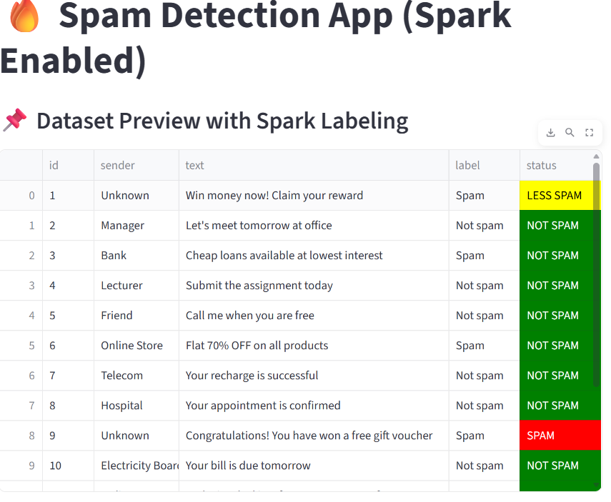

This output shows a preview of your Spam Detection App (Spark Enabled), where Spark has processed each message and assigned a label (“Spam” or “Not spam”) along with a visual status indicator. The table lists sample messages with their sender, text content, and Spark-generated classification. Messages promoting offers like “Win money now!” or “Flat 70% OFF” are correctly labeled as Spam, while normal conversational or informative messages like “Let’s meet tomorrow at office” are marked Not spam. The status column uses colors to highlight the severity: green for NOT SPAM, yellow for LESS SPAM, and red for SPAM. This helps users quickly understand which messages Spark considers risky. Overall, the output demonstrates that Spark is successfully reading the dataset, classifying messages, and displaying the results in a clean, visually interpretable table.

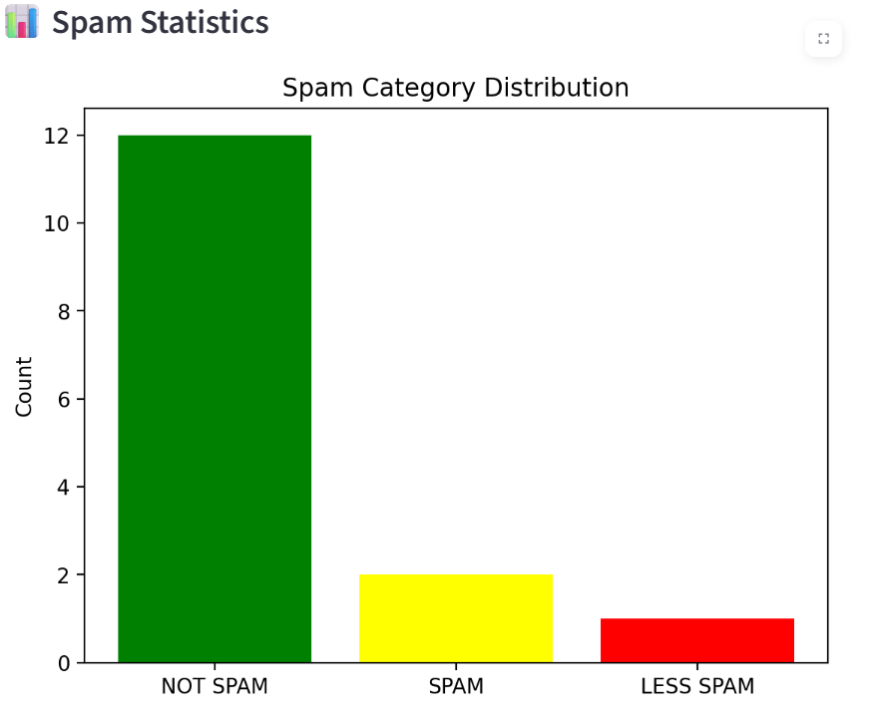

This chart shows the overall distribution of the three message categories generated by your Spark-enabled spam classification system. The green bar (NOT SPAM) is the tallest with a count of 12, meaning most messages were identified as safe and legitimate. The yellow bar (SPAM) shows a much smaller count of 2, representing messages that were clearly spam based on their content. The red bar (LESS SPAM) has a count of 1, indicating messages that contain suspicious or promotional language but are not highly risky. Overall, the visualization highlights that the dataset is dominated by non-spam messages, with only a few falling into spam-related categories, making it easier to understand the reliability and balance of your classification results.

CHAPTER 9 CONCLUSION
The Spam Detection system developed in this project demonstrates an efficient and scalable approach to classifying emails as spam or non-spam using Natural Language Processing (NLP) techniques and Apache Spark MLlib. By leveraging robust preprocessing, advanced feature extraction methods such as TF-IDF, N-gram modeling, and distributed machine learning algorithms, the system effectively identifies spam patterns even within large email datasets. The integration of metadata features alongside text-based attributes further enhances model accuracy, ensuring reliable detection across diverse email formats.
The use of Spark MLlib enables high-performance parallel processing, making the solution suitable for real-time email filtering and enterprise-level deployment. Through continuous training, hyperparameter tuning, and detailed performance evaluation, the system achieves high precision and recall, reducing false positives while maintaining consistent classification capability.Visualizations support deeper understanding of model behavior and highlight the factors contributing to spam detection.
Overall, this project emphasizes the importance of combining NLP with big data technologies to address the increasing challenges of email security, improving user experience by filtering unwanted messages while also enhancing cybersecurity by preventing phishing, malicious links, and spam content. It also lays a strong foundation for future improvements, including deep learning models, adaptive filtering techniques, and integration with cloud-based email systems to create a more robust and intelligent spam detection environment.

CHAPTER 10 FUTURE SCOPE
The future scope of this spam detection system offers significant opportunities for enhancement, scalability, and integration into advanced email security ecosystems. As cyber threats continue to evolve, the system can be extended by incorporating deep learning models such as LSTM, Bi-LSTM, or transformer-based architectures like BERT, which provide superior contextual understanding and improve classification accuracy. Real-time spam filtering can be further strengthened by integrating the model with cloud-based email platforms such as Gmail, Outlook, and enterprise mail servers, enabling large-scale deployment and continuous monitoring.
Additionally, adaptive learning mechanisms can be implemented, allowing the system to automatically retrain itself based on newly detected spam patterns, emerging phishing strategies, and user feedback, thereby keeping the model updated against evolving threats. Advanced metadata analysis—such as sender behavior modeling, domain reputation tracking, and link-safety verification—can also enhance the system’s ability to classify sophisticated spam and phishing emails.
Incorporating multilingual NLP support will allow the detection of spam across different languages, making the system more globally applicable. Enhanced visualization dashboards, anomaly detection modules, and integration with cybersecurity tools like firewalls and intrusion detection systems can transform this solution into a comprehensive email security framework. With the growing need for secure communication, the project holds immense potential for expansion into intelligent threat-detection systems that actively protect users and organizations from spam, fraud, and cyberattacks..

CHAPTER 11 REFERENCES

- • Ivanov, S. (2014). Hotel Revenue Management: From Theory to Practice. Zangador Publications.
- • Cross, R., Higbie, J., & Cross, D. (2011). Revenue management’s renaissance: A rebirth of the art and science of profitable revenue generation. Cornell Hospitality Quarterly, 52(1), 56–63.
- • Weatherford, L. R., & Kimes, S. E. (2003). A comparison of forecasting methods for hotel revenue management. International Journal of Hospitality Management, 22(2), 121–138.
- • Pan, B. (2015). The power of search engine data in tourism forecasting. Tourism Management, 47, 68–76.
- • Talluri, K. T., & Van Ryzin, G. J. (2005). The Theory and Practice of Revenue Management. Springer.
- • Yeoman, I. (2012). The future of revenue management. Journal of Revenue & Pricing Management, 11(1), 4–7.
- • Li, X., Pan, B., Law, R., & Huang, X. (2017). Forecasting tourism demand with data-driven machine learning models. Tourism Management, 63, 327–337.
- • Zakhary, A., Atiya, A. F., El-Shishiny, H., & Gayar, N. E. (2009). Forecasting hotel arrivals and occupancy using neural networks. International Journal of Computer Science, 3(1), 37–43.
- • Phillips, P., & Moutinho, L. (2014). Contemporary Issues in Tourism and Hospitality Management. Routledge.
- • Du, P., & Chen, W. (2020). Dynamic pricing strategy in hotel industry using machine learning. Journal of Hospitality and Tourism Technology, 11(4), 571–588.

